April 15, 2020

Dear SYTA Member:

The student travel industry needs you—a great leader—now, more than ever. The nomination period for the 2020 – 2021 Student & Youth Travel Association (SYTA) Board of Directors is officially open, through May 20, 2020.

SYTA relies on you to nominate yourself or another qualified, dedicated individual to be considered for a Board of Directors position. This is an opportunity for personal and professional growth, while serving the student travel community.

Nominees may only nominate themselves for one Board of Directors position: Director or Vice President. We recommend you review the Election Procedures before completing the nomination form. Up for election are two Active member positions, one Associate member position and one Vice President position. SYTA Board of Director positions are elected by the membership and the term of office is three years, August 2020 – August 2023.

If the Nominating Committee does not receive any qualified candidates, the current Board of Directors will add another year to their term of office. Vice President Steve Maehl will still move on to become President for 2020 – 2021.

Board of Director nominees must submit a complete nomination package, to be received by the SYTA office no later than 5 p.m. EDT, May 20, 2020. The nomination package includes:

- Completed nomination form.
- Candidate’s statement for the membership.
- Authorized signature that you are the owner or senior manager of your company and the designated primary contact of record with SYTA at time of application.
- Brief biography and headshot photo, preferably in .jpg format at 8x10 size with at least 300 dpi resolution.

Thank you for applying to serve on the SYTA Board of Directors.

If you have any questions or need additional information, please do not hesitate to contact me.

Sincerely,
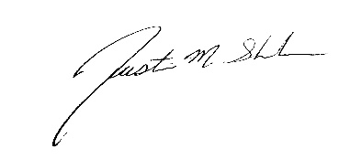

Justin Shuler
Nominating Committee Chair
SYTA Past President

