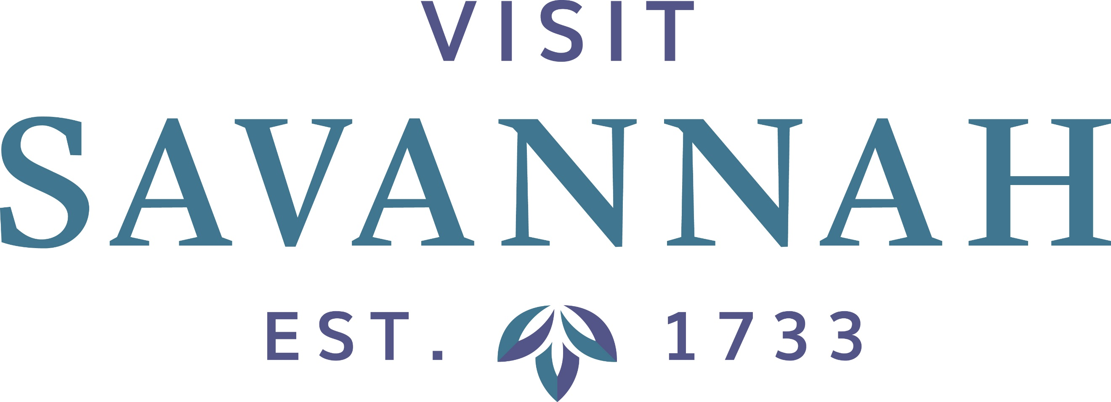

Restaurant Private Rooms
17 Hundred 90 Restaurant
307 E President St.
(912) 236-7122
https://1790restaurant.com/
Old Bar is exactly as it sounds and is behind the more commonly used bar of the restaurant, in a separate private room. It can hold and seat 35.

45 Bistro
123 E. Broughton St.
(912) 234-3111
https://www.45bistro.com/
The Atrium is 1000 square feet and can accommodate 150 reception style, and 100 seated. The glass ceiling and vine décor lends an outdoor feel to the beautiful room.
The Law room has a library or den atmosphere, and can accommodate 100 reception or 80 seated. The large doors can be left open to combine with the Atrium, for a total of 1800 square feet, 300 people for a reception or 180 seated.

Alligator Soul
114 Barnard Street Lower Level
(912) 232-7899
https://alligatorsoul.com/
The bar can be reserved for a reception of up to100. A private room is available for seating up to 20. In addition, the dining rooms can be reserved separately or together for a higher capacity; up to 100.

Belford's Savannah Seafood and Steaks
219 W. Bryan St. Suite 207
(912) 233-2626
https://www.belfordssavannah.com/
With the historic atmosphere, wonderful food and excellent service, we can help you create an unforgettable experience. Belford’s can accommodate up to 150 people and offers both buffet and seated service for groups and parties. We also cater, bringing our outstanding cuisine right to your door.

B. Matthews Eatery
325 E. Bay St.
(912) 233-1319
https://bmatthewseatery.com/
The entire restaurant, with full bar, can be rented and private dinning room seats 30.

Cha Bella Grill and Patio Bar
102 East Broad Street
(912) 790-7888
https://www.cha-bella.com/
Patio - upper/lower/combined can hold up to 200. A private Star Room inside can hold 24. This restaurant uses all local, organic products.

Chart House
202 W. Bay St.
(912) 234-6686
https://www.chart-house.com/location/chart-house-savannah-ga/
The River Room/3rd Floor can be split into sections or rented out completely, for various capacities.

Churchill's Pub
13 W Bay St
(912) 232-8501
https://www.churchillsonbay.com/
Churchill’s Underground is exactly as it sounds – the basement of the bar. It offers a private bar and dining area. It can seat 66 and hold up to 100. The Room rental fees are $75 for a Sunday-Thursday evening rental for up to 6 hours and $150 for a Friday or Saturday evening rental for up to 6 hours.
10 Downing is a separate venue on the rooftop of Churchill’s featuring a private bar and reception area with seating up to 86 and a reception capacity of 100 guests, and access to the adjacent courtyard. It has full A/V Integration and a 12 ft screen projector available at an additional cost.

Garibaldi's Café
315 West Congress St.
(912) 232-7118
https://garibaldisavannah.com/private-dining/
A beautiful and ornate Upstairs Ballroom can hold and seat 120.

The entire upstairs can be reserved. It is decorated in military and police medals and paraphanalia, with two separate rooms, a bar, and an outdoor balcony overlooking river street.

The Olde Pink House
23 Abercorn St
(912) 232-2803
https://www.theoldepinkhouserestaurant.com/
The oldest mansion in Georgia, the Habersham House, The Olde Pink House – whatever you call it, it’s old, beautiful and flexible in terms of private dining. All room rentals requires a food and beverage minimum.
The James Habersham Grand Ballroom is a recent addition to the building, with hand-painted silk wallpaper and crystal chandeliers. This exquisite ballroom exemplifies the beauty of the low country and our historic city. Like the city she is named after, 'Savannah' is warm and elegant, a perfect setting for the quintessential southern dining experience. The ballroom can comfortably hold 200 or seat 150.
The Study
The ‘Study’ with its antique heart pine flooring and walls, and gives this room warmth and serenity. Appealing on its own, this room also boasts a private balcony. The combination makes this room a must for your event. The ‘Study’ can entertain a maximum of 28.
Master Bedroom Dining Room
The largest private dining area in the original home is this 'Purple' room. Originally the master bedroom of the home, this dining room offers classic eighteenth century architecture and elegance. This room can entertain a maximum of 42 guests.
The Office
The 'Office' dining room was added in 1811 when the home became the Planters Bank. The 'Office' has a picture perfect view of Reynolds Square, and can entertain up to 24 guests. This dining room has a door for increased privacy.
The Green Room
The 'Green' dining room on the main floor with its antique heart pine flooring and decorative fireplace is a beautiful example of the Georgian parlor-dining room. This room can accommodate up to 32 guests. There is the Conference Room beyond it; therefore
The Conference Room
This room on the main floor, beyond the Green Room, was added when the house became the Planters Bank. This room can accommodate up to 14 guests.

The Pirates' House
20 East Broad Street
(912) 233-5757
https://thepirateshouse.com/
The oldest structure in Georgia is the Herb House, which can seat 13.
The Anne Bonny Room can hold and seat 50.
Captain Flint's Hall can hold or seat 150.
The Lookout is an upstairs room only accesible by stairs that can hold and seat 130.

Vic's On The River
26 East Bay Street
(912) 721-1000
https://www.vicsontheriver.com/
The Stoddard Room is 2300 square feet and can hold 175 with seating for 160
The Dieter’s Den is 600 square feet and can hold or seat 50

Wexford Savannah Iris Pub
315 W Congress St
(912) 232-7118
https://www.wexfordpub.com/

Sorry Charlie’s Oyster Bar & Cocktails
116 W. Congress Street
(407) 949-4603
https://www.sorrycharlies.com/private-events/

The Lady and Sons
102 W. Congress
(912) 233-2600
https://www.ladyandsons.com/

Local 11ten
1110 Bull St
(912) 790-9000
https://www.local11ten.com/

Java Burrito
420 E Brought St
912-298-5282
https://javaburrito.com/template-page

The Vault Kitchen
2112 Bull St
912-201-1950
https://thevaultkitchen.com/savannah-starland-district-the-vault-kitchen-and-market-party

Tubby’s Tank House Thunderbolt
2909 River Dr
912-354-9040
https://www.tubbysthunderbolt.com/

River House Seafood
125 W River St
912-234-1900
https://www.savannahriverhouse.com/

Madame Butterfly
110 W Congress St
912-999-8539
https://madamebutterflysavannah.com/

Saint Bibiana
700 Drayton St
912-721-5002
https://www.saint-bibiana.com/

Stone & Webster Chophouse
400 W River St
912-373-9006
https://www.plantriverside.com/restaurant-bar/stone-webster-chophouse/

Plant Riverside District Resturants
400 W River St.
https://www.plantriverside.com/restaurant-bar/

Fleeting
201 Port St.
912-521-6150
https://www.fleetingrestaurant.com/

