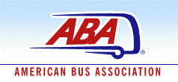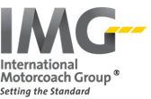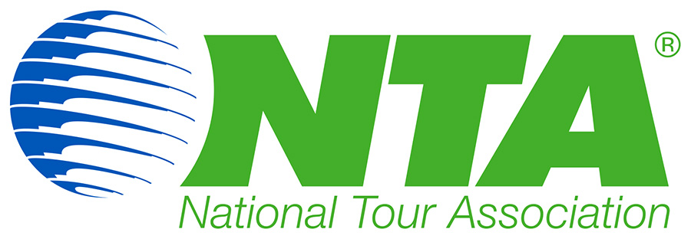

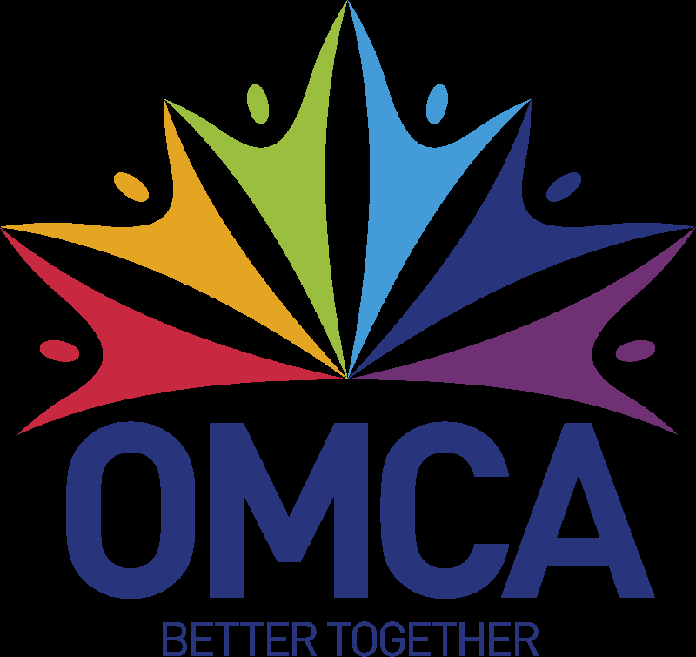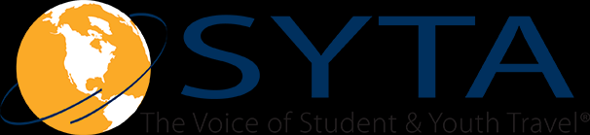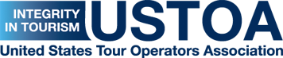

November 10, 2017

Secretary Ryan Zinke
U.S. Department of the Interior
1849 C Street, N.W.
Washington, D.C. 20240

Dear Secretary Zinke:

The travel and tourism industry, which includes a range of organizations that represent the business interests of commercial tour operators and motorcoach travel, is concerned about the U.S. National Park Service’s recent proposal to increase fee schedules, mandate commercial use authorization permits and establish seasonal peak pricing on commercial entry fees at 17 national parks.

As representatives from the National Tour Association, United States Tour Operators Association, American Bus Association, International Inbound Travel Association, United Motorcoach Association, Student & Youth Travel Association, Ontario Motor Coach Association and International Motorcoach Group, we recognize the need to maintain and improve America’s national parks. However, we believe the NPS goals can be achieved through more thoughtful measures that will not jeopardize the role the travel and tourism industry plays in promoting the enjoyment of our national parks and creating jobs. We want to work with your department to enhance the experiences these treasures offer travelers. As a starting point, we need to consider how best to meet the objectives, in terms of setting reasonable price increases and, specifically, the timing of any sort of increase. Both issues directly affect our members and our ability to provide the access and services demanded by them.

National parks are among America’s top destinations, and our industry has consistently advocated for park funding. While we recognize that additional fees are needed to preserve our nation’s natural treasures, we are concerned the lack of a more staged implementation period to fairly and equitably implement the fee increase into tour packages will be burdensome on users of the parks and tour companies. We also are concerned about the reasonableness and size of the proposed increase. Our organizations help to ensure that the movement of people through our parks is as efficient as possible. For example, just one bus can take up to 55 cars off the road, providing congestion and environmental benefits to all park users. Commercial buses and tour groups are critical to the economic health of the NPS. In FY 2012, commercial bus fees were the third highest revenue related source for the parks. That standing only has increased in recent years behind record breaking visits from the travel and tourism industry, due in part to the support from the listed associations. Each of our organizations is proud to be able to offer access to tourists to our parks, and each of us is active in promoting our programs.
As mentioned in a 2015 Department of Interior Office of the Inspector General’s Audit Report titled “Review of the National Parks Service Recreation Fee Program,” the associations represented on this letter have had a longstanding agreement with the NPS that we would be notified 18 months ahead of any entrance-fee increases to enable pricing adjustments. This is critical for our members and their customers, as many companies book tour groups months, if not years, in advance. With the recent announcement, we are concerned about how this will impact not only our tour companies and their customers, but also the area concessionaires and the local destination attractions that serve these visitors near the parks.
In addition, the NPS proposal reflects a significant agency action, which will have a substantial impact on the public. We would urge the department to follow the requirements of the Administrative Procedures Act, and at a minimum, publish the Notice of Proposed Rulemaking Proposal for notice and comment in the Federal Register. In fact, the NPS has published similar fee increase notices in the past, such as a “Proposed Fee Schedule for Commercial Filming and Still Photography Permits,” under NPS-WASO-VRP-14127. In this federally managed docket forum, not only will the public have a full opportunity to properly engage in the comment process, but it also will enable and facilitate interagency review by entities such as the Small Business Administration, which often likes to review and comment on the policies that will have a significant impact on small businesses. In avoiding the Federal Register process, you may be inadvertently giving off the impression that you are trying to avoid receiving meaningful or wide-ranging input.
Last year, the NPS celebrated its centennial anniversary, and the travel and tourism industry cheered alongside it. In that same year, the NPS recorded a whopping 330 million recreational visits, up significantly from what had been a record-breaking 307 million visits in 2015. If the currently proposed fee increases are implemented, those record numbers will not continue to climb. An interesting study was conducted by Seth Factor in 2007, which looked at the impacts that just a 10 percent increase would have on visitor arrivals at national parks. What is proposed far exceeds that, as well as the 30 percent fee increase recommended by DOI OIG Audit report. We also would remind you of a key term within 16 USC 6802(c), the recreation fee authority, which authorizes you to collect these fees that you propose to increase as mandated by the Federal Lands Recreation Act (Public Law 108-447):
“The Secretary shall establish the minimum number of recreation fees and shall avoid the collection of multiple or layered recreation fees for similar uses, activities or programs.”
In the case of this proposal, for example, commercial bus tours will be paying at least three different fees related to the same visit. Since a bus and tour operator who are working together on the same trip may both need to pay the same annual management, application and CUA fees, the visitors may be hit with the same fees, which are being passed onto them twice. We do not feel that is in the spirit of 16 USC 6802(c), in addition to the significant pricing, permitting and paperwork burden on our operators.

As the NPS closes out its impressive 101st year, the public is visiting and appreciating our national parks more than ever. To help continue this trend, we ask for the Department of Interior’s cooperation in solving this problem together. The solution to our great parks’ needs cannot and should not be shouldered by its visitors—we can fix this together.

As you know, these issues are very important to our organizations, and we would very much like to further discuss these contemplated policy changes. We look forward to working with you and your team in the near future.

Sincerely,

American Bus Association
International Inbound Travel Association
International Motorcoach Group
National Tour Association
Ontario Motor Coach Association
Student & Youth Travel Association
United Motorcoach Association
United States Tour Operators Association

